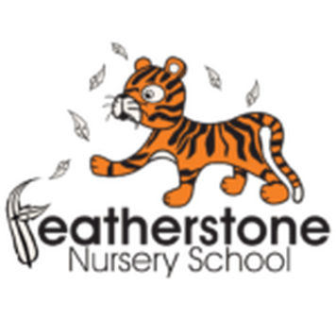
Featherstone News
https://www.featherstonenurseryschool.co.uk February 2026 
Nursery News:
Welcome to our February newsletter! This month brings lots of wonderful learning opportunities, and celebrations.
Well done to all of the new children that have started in Little Learners and Explorers during January. They have settled really well! Our lovely practitioners have worked hard to help your child feel safe and happy and given them a sense of belonging at our nursery.

Some children have moved up from Little Learners to Explorers – the visits before Christmas really helped their transition. Well done to you too!
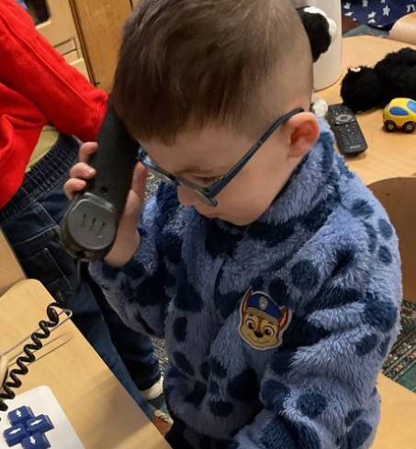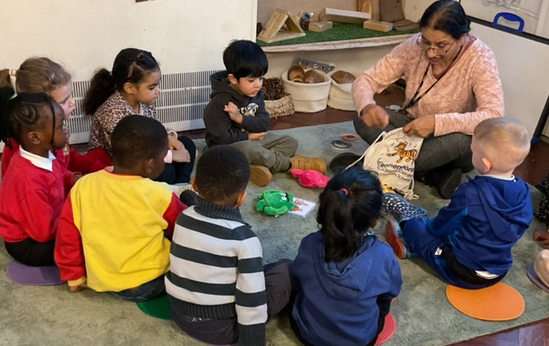

Dates for your diary:

Thursdays: Stay and Play (under 2s) every Thursday morning – 9:45 – 11:15am at OSBORNE NURSERY SCHOOL.
Wednesday 4th February – The Playhouse Theatre will be visiting!!
WC: 9th Febuary – Parent/ carer progress meetings – make sure you have booked your appoitment with your key worker.
Monday February 16th– Friday February 20th – HALF TERM – nursery closed for all.
Wednesday 4th March – World Book Day celebrations
Monday 30th March – 10th April - Easter holiday – nursery closed
Please remember to telephone us on 675 3408 if your child is too ill to be at nursery. Please keep us updated with any changes of address or phone numbers. Please let Rachel or Rebecca know at our office.

Attendance is very important at Nursery. We like to see you for all of your sessions each week. We like families to aim for attendance to be between 95 and 100%. Look out for the Cool Kittens stickers
Congratulations to RABBITS AM and CATERPILLARS PM for the best attendance in Nursery in January 2025. FANTASTIC!! Well done to the parents and carers too.

Self help skills:
As part of your child’s learning journey, we practice self help skills. We encourage your child to be independent:
Taking off a coat
Putting a coat on
Toilet training
Drinking out of a cup
Using a knife and fork
Washing own hands
Any support at home with these skills would be fantastic!


This year we will be working towards reaccrediting our Rights Resecting Award. You will have seen our posts about ‘ I have the right to a name’ and’ I have the right to play’
Terry the Tiger is helping the children understand their rights and use the language of rights.

Rights Respecting Schools Award (RRSA)


SAFER INTERNET DAY –Safer Internet Day takes place in February of each year to raise awareness of a safer and better internet for all, and especially for children and young people. Our children will be reading a story all about a penguin that learns how to stay safe when using the internet.
February’s message: Its ok to UNPLUG for a few hours – children need a break and should be encouraged to do something else. They could play with toys, visit family/ friends or run around outside. You’ll both benefit if you ignore the messages on your phone whilst playing or talking with your child. ( You’ll save some elecrticty too!)

It is great to see the children bringing back their library books every Wednesday – we hope you are enjoying reading at home.
Recommended reading this month:
Traditional Tales
There are lots of versions of Goldilocks and the Three Bears. See if you can find the story in the library or online
Keep reading every day too – talk about the pictures and see if your child can retell the story.

Remember our Startwell messages too! We try to make links for our children to help them recall stories and past events. Maybe you could try making some porridge at home – just like the three bears – try not to add sugar – think about the different foods you could add that have less sugar. 

Please keep up to date with messages and photographs on Tapestry. Each term you will receive a progress report written by your child’s key worker. This will explain what they do well and targets to help them achieve even more!
We would like to wish all of our families a very happy Luna New Year.
We will be learning about Luna New Year and the children will take part in different learning activities.
This year is ‘Year of the Horse’ and is all about energy, freedom and adventure.
There are lots of events on in Birmingham – details will be posted on Tapestry .

